MINISTRY OF CULTURE AND INFORMATION POLICY OF UKRAINE
KHARKIV STATE ACADEMY OF CULTURE
INSTITUTE OF CULTUROLOGY OF THE NATIONAL ACADEMY OF ARTS OF UKRAINE
DEPARTMENT OF CULTURE AND TOURISM OF KHARKIV REGIONAL STATE ADMINISTRATION
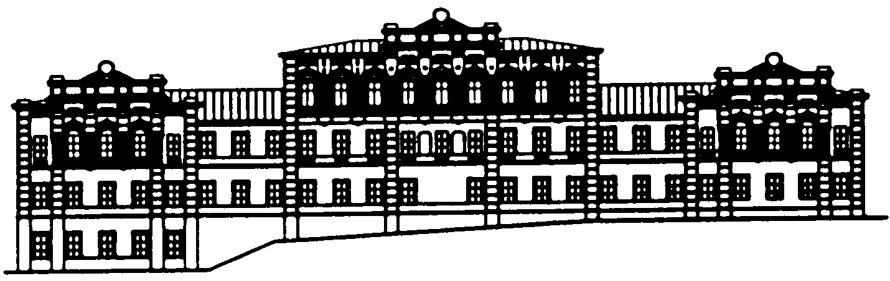

November 17-18, 2022
International scientific conference
CULTURAL STUDIES AND SOCIAL COMMUNICATIONS:
INNOVATIVE DEVELOPMENT STRATEGIES

Thematic blocks:
1. Methodological and theoretical problems of culturology and social communications
2. Ukrainian and world culture in the conditions of civilization dynamics
3. Philosophical and socio-political dimensions of the modern culture
4. Current issues in the history of museum and monument studies
5. Historical, cultural and socio-economic dimensions in tourism
6. Socio-psychological factors and conditions of human mental well-being
7. Documentary and communication structures of society: theories, strategies, innovations
8. Information and communication technologies of the global socio-cultural space
9. Theatrical art in the modern scientific discourse
10. Theoretical and applied problems of audio-visual art and production development
11. Modern strategies and models of socio-cultural activities
12. Language and literature in the context of geocultural changes
13. Musical art in the space-time of culture: past and present
14. Choral art in cross-cultural space
15. World and national trends in choreographic art: past and present
16. Modern European languages in professional and scientific communication
17. Oriental studies

The conference will be held online on the Zoom platform. The conference program with the necessary links will be posted the day before the conference on the official website of the Academy - https://ic.ac.kharkov.ua/ Ukrainian and English are the conference working languages.

Materials submission deadline and conditions

The submission deadline is October 25, 2022 (please send abstracts to the e-mail address rvv2000k@ukr.net) It is necessary to add to the abstracts: the scientific adviser’s review (for students and postgraduates), and an application form.
The volume of the materials: 2-3 pages, A4 format, margins 20/20/20/20 mm, font Times New Roman 14, interval - 1.5. The author’s initials and surname (co-authors) are given in the upper right corner of the page (in Ukrainian and English). From the next paragraph in the centre - the title of the report in capital letters in two languages (Ukrainian and English). Below across the width of the page - theses.
The application form for participation in the conference is submitted after the abstracts, on the next page. The responsibility for the observance of academic integrity rests entirely with the author. The Organizing Committee reserves the right to select abstracts.

Financial terms of participation in the conference:

Taking into account military actions, the editorial department will accept theses without payment. All participants of the conference will receive electronic certificates (12 hours of professional development), a program and a collection of works in the e-mail indicated in the questionnaire.
If desired, authors can order printed versions of the certificate, program and collection at an extra charge, which must be specified in the participant's application form. The amount of payment together with bank details will be notified to customers after the end of the theses’ acceptance (after October 25, 2022).

For all questions, please contact the organizing committee by the address:
61057, Kharkiv, Bursatsky Uzviz, 4, Kharkiv State Academy of Culture, Editorial and Publishing Department. Phone: (057) 731-27-83, (057) 731-34-97. E-mail: rvv2000k@ukr.net
PARTICIPATION REGISTRATION FORM
INTERNATIONAL SCIENTIFIC CONFERENCE
Full name:  If there are co-authors – put the full name of each co-author separately | Author 1
 | Author 2
 | Scientific adviser
Participant's status:  PhD \ Researcher  - Title \ academic degree and position, institution (university) \  - A year of study, degree, the place of education (university) | Author 1
 | Author 2
 | Scientific adviser
E-mail: | Author 1
E-mail: | Author 2
E-mail: | Scientific adviser
Telephone: | Author 1
Telephone: | Author 2
Telephone: | Scientific adviser
Contact e-mail for correspondence (if there are several authors)
Topic of the report \ paper
Thematic blocks \ Specialty  - Choose one option | 1. Methodological and theoretical problems of culturology and social communications  2. Ukrainian and world culture in the conditions of civilization dynamics  3. Philosophical and socio-political dimensions of the modern culture  4. Current issues in the history of museum and monument studies  5. Historical, cultural and socio-economic dimensions in tourism  6. Socio-psychological factors and conditions of mental well-being  7. Documentary and communication structures of society: theories, strategies, innovations  8. Information and communication technologies of the global socio-cultural space  9. Theatrical art in the modern scientific discourse  10. Theoretical and applied problems of development of audiovisual art and production  11. Modern strategies and models of socio-cultural activities  12. Language and literature in the context of geocultural changes  13. Musical art in the space-time of culture: past and present  14. Choral art in cross-cultural space  15. World and national trends in choreographic art: past and present  16. Modern European languages in professional and scientific communication  17. Oriental studies
Would you like to receive a printed version of:
- a certificate |  | yes/no
- a program |  | yes/no
- a collection |  | yes/no
City, “Nova Posta” department number, phone number
(for those who wish to receive a printed certificate/program/collection)

